NATUTAMA FOUNDATION
Summary of activities for 2022

Introduction
After two years of adjusting to Covid conditions, Natutama had a very productive year in 2022. Following re-roofing and re-painting early in the year, the Interpretation Centre received over 4000 visitors and, after a gap of 2 years, once again brought in enough income to cover Centre guiding and other outgoings. Given the way prices are rising in the area, this was a great relief, and we were helped by special donations from some funders, including Colombian NGOs. In particular, our energy crisis will finally be resolved with a combination of solar and local power.

Schools returned to normal and it was also possible to visit community schools again. We began work in a community on the Loretoyacu and expanded pedagogical training for local educators. We also included more elders in workshops leading up to the celebration of Natutama Week.

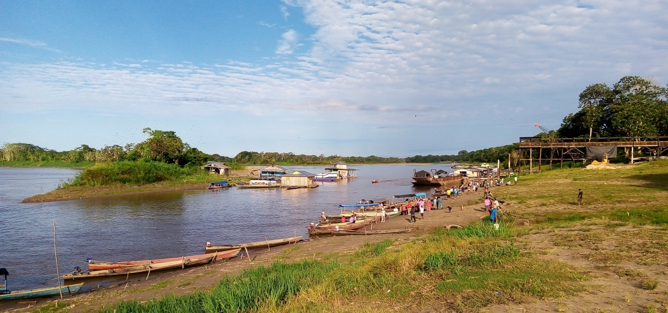
Puerto Nariño is now at the mouth of the river Loretoyacu (right) as it flows into the Amazon (left)

Wildlife monitoring
The high and low water seasons were less marked than usual, with long periods of transition when aquatic animals spend more time in the main lakes. Once again, fishermen saw large groups of up to 10 giant otters in both the Tarapoto lakes and the Atacuari area. The only manatee hunting incident was recorded in the Atacauri on the border with Peru and the Natutama fisherman warned the hunter of severe penalties in both countries. Although we recorded fewer sloths than normal in the February count (8), many more were sighted through the year.

Manatees
The fishermen recorded 184 manatee sightings in the Puerto Nariño area during 2022, more than they had seen in any year since 2018. They also registered 4 calves, which is encouraging. Over half the sightings were made in the main Tarapoto lakes and fewer manatees were seen in the flooded forest and more distant lakes, mainly because the river did not flood for as long as usual.

For the Atacuari area, more manatees were recorded than ever before, with 238 sightings, including 9 calves. Very large groups were seen in backwaters of the river Amazon, above and below the mouth of the river Atacuari. In August, the Atacuari fisherman recorded 24 manatees in one day, in groups of 5, 4, 7 and 8 manatees in different backwaters upriver. At the same time there were some 10 manatees downriver from Atacuari and at least 7 in the Tarapoto lakes, for a grand total of over 40 manatees in the area. It is most unusual and very satisfactory to have this spread of monitoring data.

It seems that the manatees from the Tarapoto lakes are moving upriver towards Atacuari for the low water summer season – this is probably because there is so now much river traffic to Puerto Nariño, as well as relatively few backwaters in the area suitable for manatees. During the high water period, when there is far more habitat available, the manatees spread all through the lakes, with sightings of 1 to 7 manatees per survey.

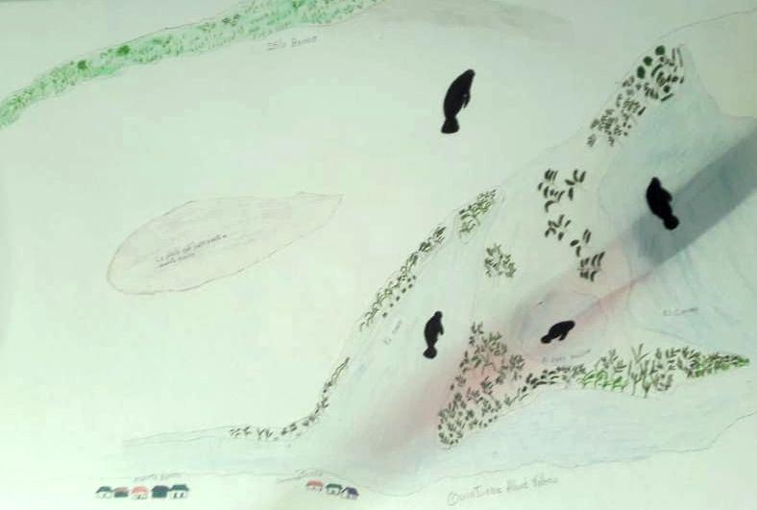
Manatee sightings close to Puerto Nariño

Dolphins
The total number of dolphins registered in 2022 was slightly lower than 2021, with 1087 sightings, an average of 22.7 dolphins per survey. The maximum number sighted in one day was 80, higher than the year before. However, the number of Inia recorded continues to drop compared with Sotalia, and in 2022 only 385 (34%) of sightings were of Inia, with a maximum number of 32 seen in one day. An additional 71 Inia were recorded in the flooded forest by the manatee monitor. Six Inia calves and 11 Sotalia calves were also seen.

Fifteen years ago, Inia sightings accounted for over 50% of the total - clearly the number of Inia killed in conflicts with fishermen in Peru and Brazil has taken a toll on the local population. Also, sightings in the lakes have dropped in the last two years, perhaps because of the changes at the mouth of the river Loretoyacu, which have affected one of the areas much used by dolphins and fishermen: the port, with much river traffic, is now right at the entry of the river instead of further in. The meeting of the Amazon and Loretoyacu currents provided a profitable fishing ground, where birds, canoes and dolphins could usually be seen.

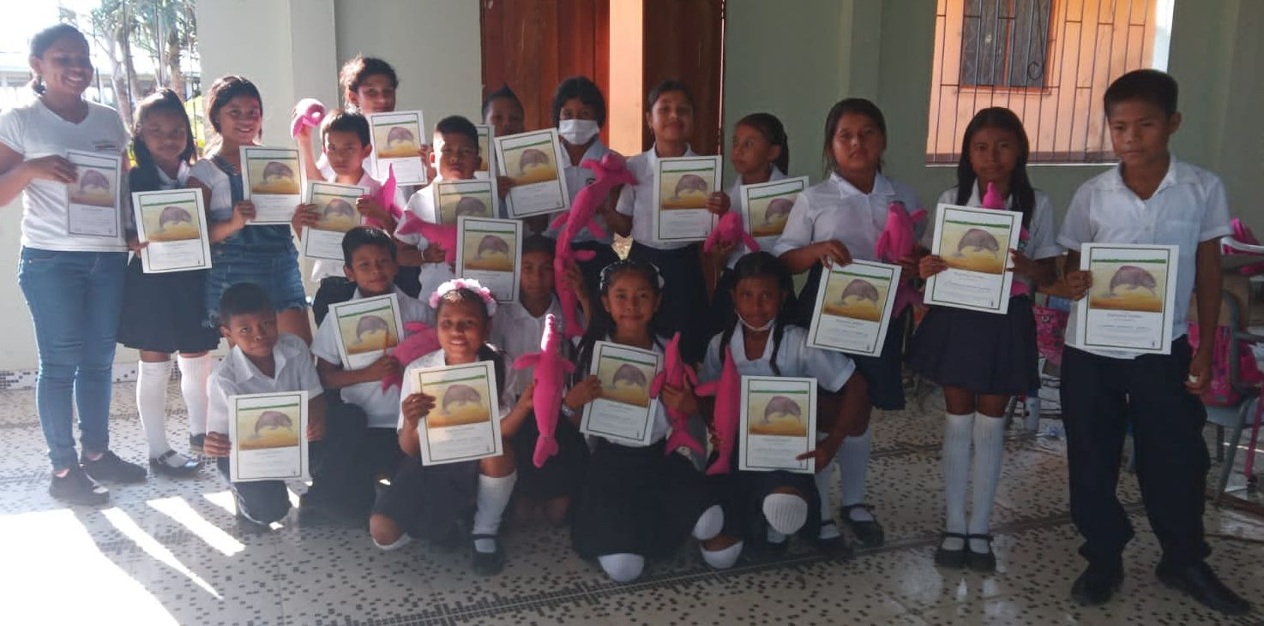
5th grade in school with dolphin diplomas & the dolphins they made

Education
This was the first year after Covid with school classes back to normal and Natutama educators worked with 381 children in all primary grades during the first semester. At first the children were timid and reluctant to take part and appeared to have lost ground in reading, writing, drawing and memory. But as the workshops progressed, they regained confidence and participated far more in class.

In the second semester, the educators worked with small groups in neighbourhoods or ‘Barrios’ of Puerto Nariño, continuing the programme implemented under Covid restrictions. One of the benefits of these groups is the interest taken by parents and other adults, who take part in some workshops. At the same time, they continued with the two main junior ecology groups in Puerto Nariño and Puerto Esperanza.

Ecology group (G.E.) or Barrio (B.) | # children | Ages
G.E. Amiguitos de la Ceiba | 15 | 2 - 11 yrs
G. E. Hijos de Metare | 15 | 3 - 14 yrs
B. Loma linda y 13 de mayo | 15 | 5 - 12 yrs
B. Progreso y 8 de diciembre | 20 | 5 - 10 yrs
B. Centro y Baos | 15 | 5 - 12 yrs
Total | 80 children

Themes covered included the origin of jungle gardens, the story of the River Amazon and lakes, flora and fauna of the flooded forest, beaches and backwaters, my house, my community, the Ticuna, Cocama and Yagua people, food and fishing, and a visit to the Natutama Centre.

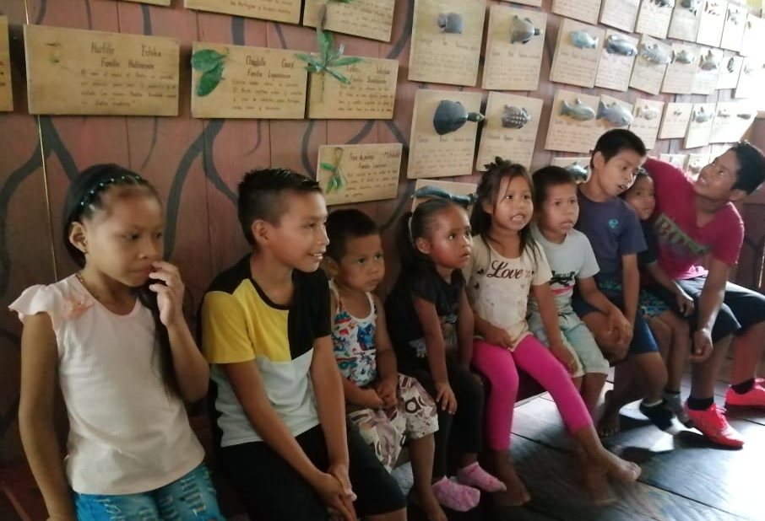

Education in communities
In 2022 a former Natutama educator living in the community of 12 de Octubre upstream on the river Loretoyacu began a programme in the primary school, which has 100 children. The themes were chosen with the participation of parents and included the knowledge and use of flora and fauna and the management guidelines set out by the Indian Resguardo organization. In addition, Natutama educators held workshops in four other communities, including San Antonio in Peru. Natutama’s work in communities is very well received by local leaders, who would like to have more visits by the Foundation.

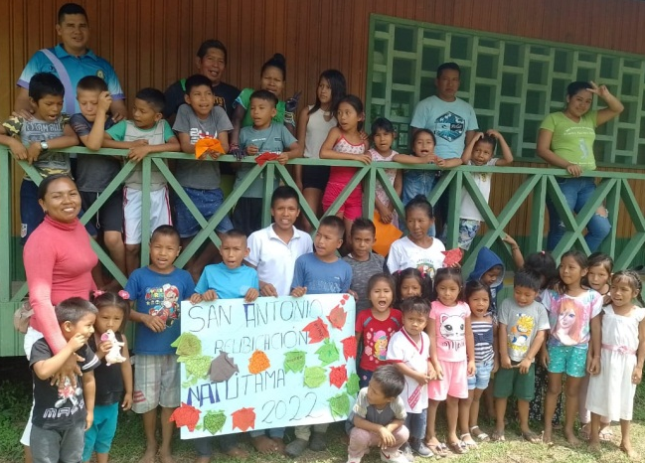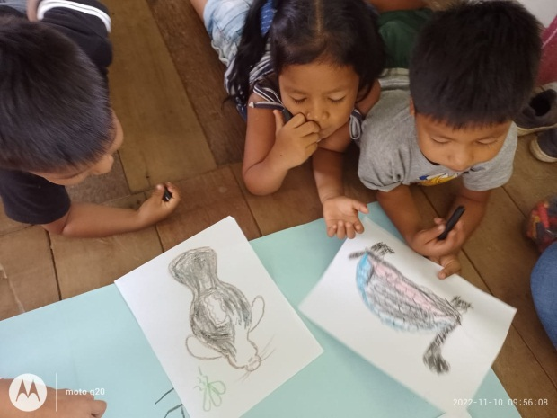

Natutama Week
The main theme for Natutama Week was “The cold and the rain”; the cold refers to the Friaje, very cold spells caused by air masses in the southern part of the continent. Indigenous elders have been commenting on the changes associated with these cold spells and the difficulty in predicting when and how intense they will be. In the months before Natutama Week, educators held workshops with elders to collect information on past Friajes and Ticuna rituals related to the Friaje and to rain in general.

During the week, some 400 children and 100 adults took part in activities related to the main theme and to climate change, the spirits of the rain and the cold: they made masks and presented a puppet show and a dance and took part in games, painting and story telling sessions.

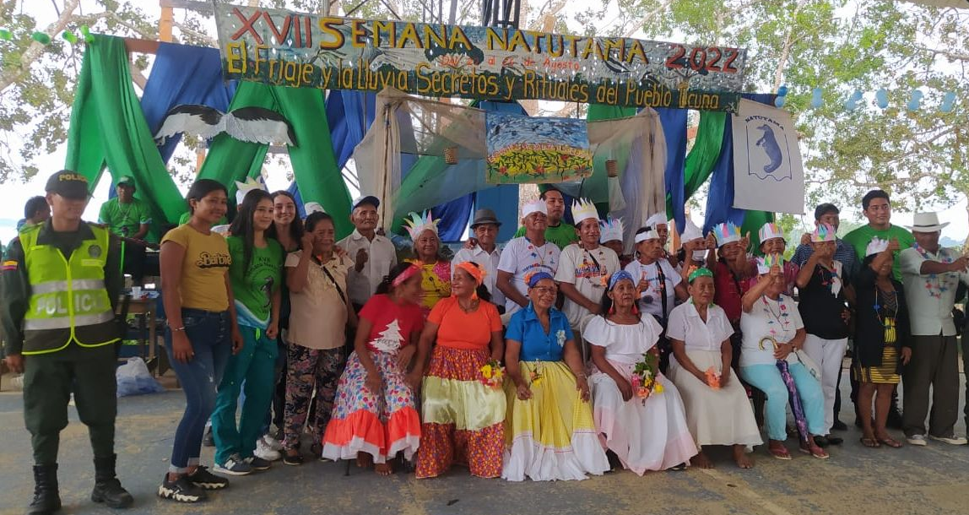

Special workshops centred on pedagogical methods and working in the barrios were also held with Natutama and other community educators and with mothers of children involved in our programme.

Apart from the material prepared for Natutama Week, which included a booklet on the spirits of the Friaje and the rain, we also edited a picture story on manatees. Using paintings by the Natutama educator in 12 de octubre, the picture tell the Ticuna story of the origin of the manatee, based on a version given by an elder in Tarapoto. There is no text, with the idea that the story can be told in any of the local indian languages or Spanish or Portuguese. Below are some of the story paintings:

Looking ahead
In 2023 we shall be expanding community education work, with a more permanent presence in Naranjales, Atacuari and San Antonio, as well as keeping up 12 de Octubre. New funding covers this venture, but we want to continue with all our other commitments in the Puerto Nariño area. For Natutama Week, educators have chosen the theme of the Sun, with all its physical and cultural connotations.

Natutama educators and fishermen have been asking, with good grounds, for an increase in subsistence payments and we are raising their stipends from January. We hope we shall be able to continue with all the wildlife monitoring and education programme as before.

N

The Natütama team 2022
Director: Clara Ximena Torres (founder member)
Education coordinator in the Amazon: Marelvi Laureano
Centre coordinator: Karina Laureano (Jan-June), Linder Napuche
Monitoring coordinator: Edgar Pinto
Education adviser: Diana Luz Orozco (founder member)
Conservation adviser: Sarita Kendall (founder member)
Amazon communications and back-up: Rocio Perdomo

Selvando educators and Centre guides: Marelvi Laureano, Karina Laureano, Edgar Pinto, Stefany Carvajal, Obsimar Lopez, Omar Lopez, Dikson Coello, Rodolfo Macedo, Linder Napuche, Betsabe Vela.
12 de Octubre community: Robert Ahue
Coinvestigators: Casimiro Ahue, Pedro Ahue, Jesus Uriel Peña, Luis Hernando Peña, Luis Ahuanari.
Legal affairs and accounting: Cesar Hernandez, Alejandro Ruiz

With special thanks for their support:
Children of Colombia, Lindsay Foundation, Othmar-Bamert-Stiftung- Lucerne, Whale & Dolphin Conservation, Fundación Unámonos, Douglas Farah, Peter Gerstrom, Nicholas and Sue Morris, Brian Moser, Titus Moser, Robin Sadler, Beatriz Vejarano, Sally Wilson, Alison Wood, David Allinson, Rosa Bonet, Ester de Miguel.

Junior ecology group: games on the newly painted floor of the roundhouse
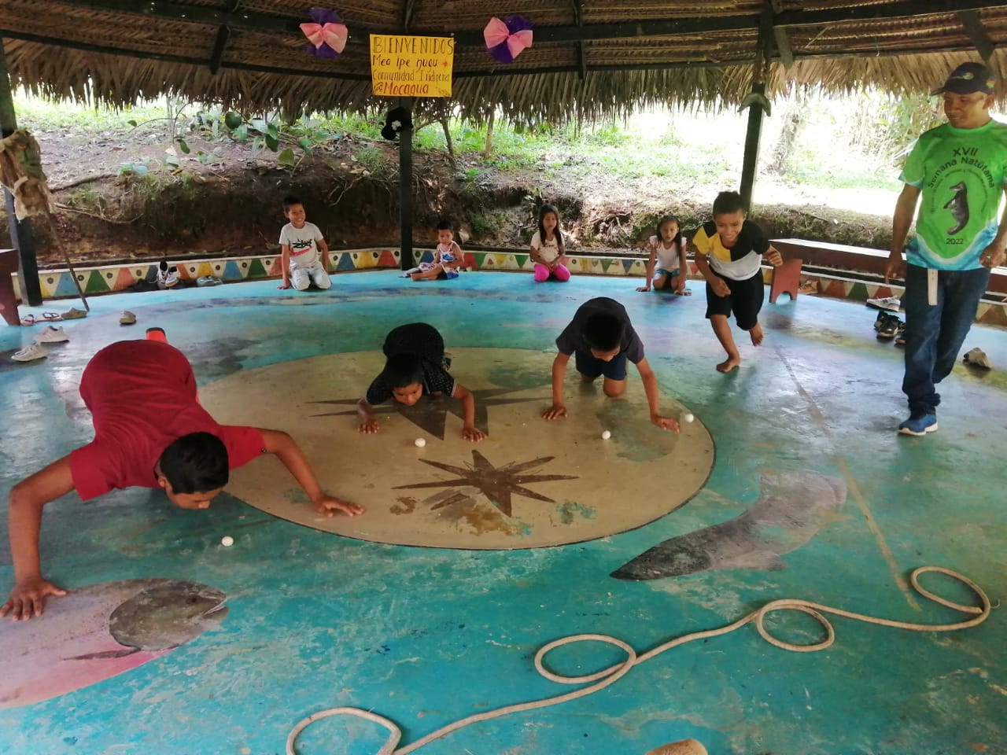

E

Ec

